Guidance on Home Learning
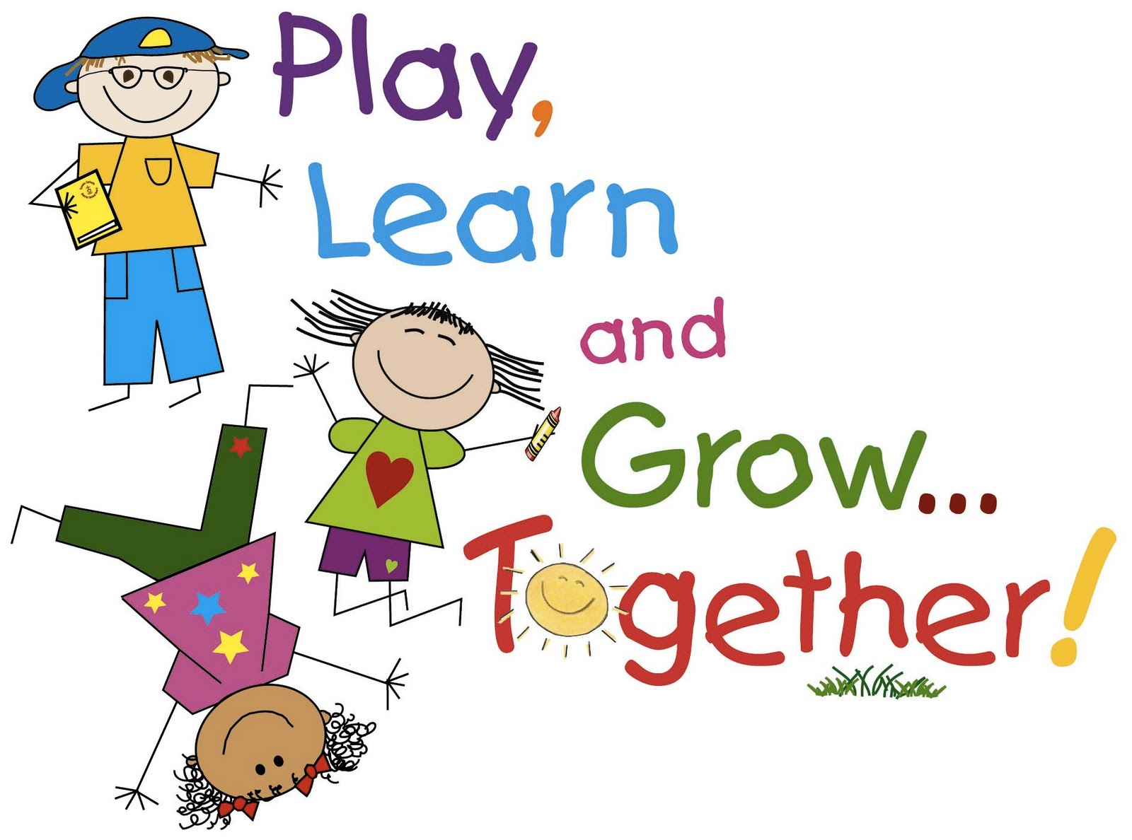

We understand that parents/carers may appreciate some advice on how to organise their home learning activities. We have provided each year group with a learning wall for Literacy, Numeracy and Topic via the school website. It is important to be aware that working one to one or in a small group is much more intensive than a classroom setting. Children will find it challenging to take part in learning for a full day at home in the same way that they would at school.
Therefore we are making the following recommendations to support pupils and families:
- A maximum of an hour of Literacy and Numeracy each day is sufficient
- It will be necessary to break the time up into smaller portions of 20 minute activities for younger children and longer periods of 30/45 minutes for older children
- Variety is important – during a literacy hour children may spend 20 minutes on spelling, followed by 20 minutes on writing and 20 minutes on reading
- Similarly with maths, 20 minutes on games or online activities followed by the use of concrete materials and visual activities before any written work is also advised
- Children tend to focus better on Literacy and Numeracy activities in the morning before lunch with more hands on activities such as Art and Topic taking place in the afternoons where possible
- Try to offer variety from day to day, if you are working on spelling and reading on one day think about changing to writing the next
- Similarly with Numeracy and Maths, if you are working on numeracy concepts, e.g. addition and subtraction look to change to shape and measure activities on subsequent days to keep children engaged
- It is important to provide breaks between subject areas; this could be structured play with construction materials/board games/drawing etc. or outdoors play if you have the space available
- Free play and free time is also important, children require breaks between learning to help them internalise new ideas and concepts
- Dividing the day between learning time and family/free time is important – agreeing on a basic structure/timetable and displaying it may help
- Families will have their own arrangements for screen time; however children spending extended periods of time online and/or watching TV may be become irritable and bored
- Children thrive on consistency and routines - these will help to keep families happy and entertained
Differentiating between week days and the weekend is important, remember to take time off. A regular routine will support children during the school closure. Ultimately you need to be responsive to your child and their mood and needs. Try not to get into arguments or disagreements over tasks and activities. If you are feeling overwhelmed by the content – take a break. Encouraging your child to continue to read regularly will support them enormously during this period of time.
We appreciate your help and support with the home learning activities.

