Task 1 | Task 2 | Task 3
The Human Body  The Skeleton  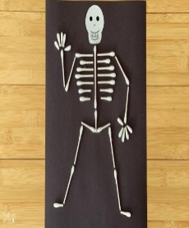  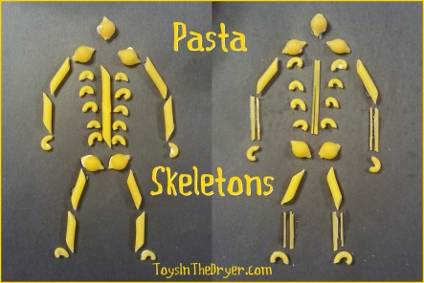  You can find information about skeletons here:  https://www.bbc.co.uk/bitesize/clips/zmptsbk  https://www.dkfindout.com/uk/human-body/skeleton-and-bones/  Make a skeleton using cotton buds/pasta/twigs etc. Label the common bones.  Explain the function or our skeletons. | The Human Body  The Heart  You can find information about the heart here:  https://www.dkfindout.com/uk/human-body/heart-and-blood/  Complete the attached cloze passage.  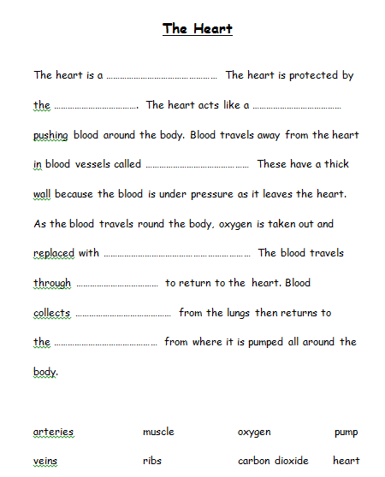  You can also try to make a model of the Circulatory system.  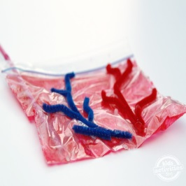  https://kidsactivitiesblog.com/8992/learn-about-the-heart-2/ | The Human Body  The Brain  This video has a lot of interesting information about the brain.  https://www.youtube.com/watch?v=lxAZC7pb-o4  Create a factfile/poster about what you have learned about the brain.  Here is a fun activity to try with someone at home. Read the words, not the colour. It’s harder than it looks! 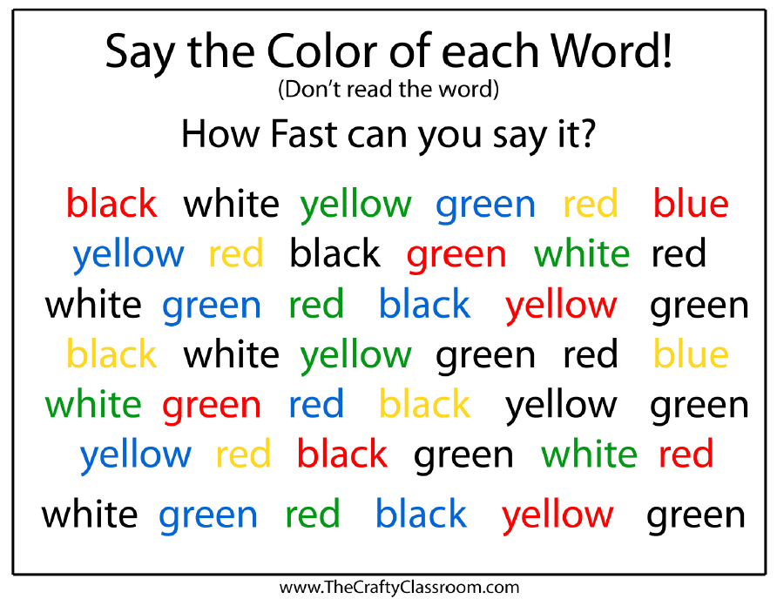
Task 4 | Task 5 | Task 6
H.W.B.  Healthy Eating in School  Watch this clip to remind you of how to keep your body healthy.  https://www.bbc.co.uk/teach/class-clips-video/science-ks1-keeping-my-body-healthy/zk4dwty  Design a new school menu. What could you add? What would you keep the same? Will it be a healthy school menu? Can you find pictures or draw pictures to add to your menu? Plan out your menu. Will you have a different menu every day?  You can find our current menus here:  http://hillheadprimaryglasgow.org/parentzone/lunch-menus/ | H.W.B.  Healthy Eating at Home  Plan a day’s healthy eating for you and your family using the Eatwell Plate model.  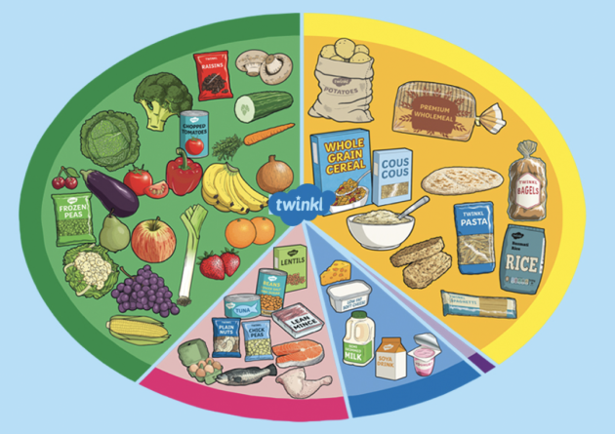  Think about what you would like to eat and draw it or make it from playdoh etc. Remember to make sure it is balanced! | Physical wellbeing  Dance  This block we have been learning different styles of dance.  Watch this video which will allow you to practise your dance skills and yoga poses!  https://www.youtube.com/watch?v=qGxwihdAaY0  